BIT 4107-Mobile Application Development
ENHANCED PROFESSIONAL STUDENT LOGBOOK
Student name: NICOLE CHEPKEMBOI
Admission Number: BIT/2024/ 54291
School/Faculty: COMPUTING AND INFORMATICS
Program me:
Academic Year: 3
Semester: 2
Lecturer: MICHAEL NYORO
Phone Number:0723402713

WEEK 1: INTRODUCTION TO MOBILE APPLICATION DEVELOPMENT
TOOLS AND SOFTWARE USED
Android Studio
VS Code
Android Mobile phone

PERSONAL REFLECTION
Developing this project using Android Studio and VS Code significantly enhanced my technical skills. Integrating a physical Android mobile phone for testing provided crucial real-world feedback, allowing me to troubleshoot performance issues effectively. This experience deepened my understanding of mobile application development and highlighted the vital importance of real-device testing.

WEEK 2: MOBILE DEVELOPMENT ENVIRONMENT
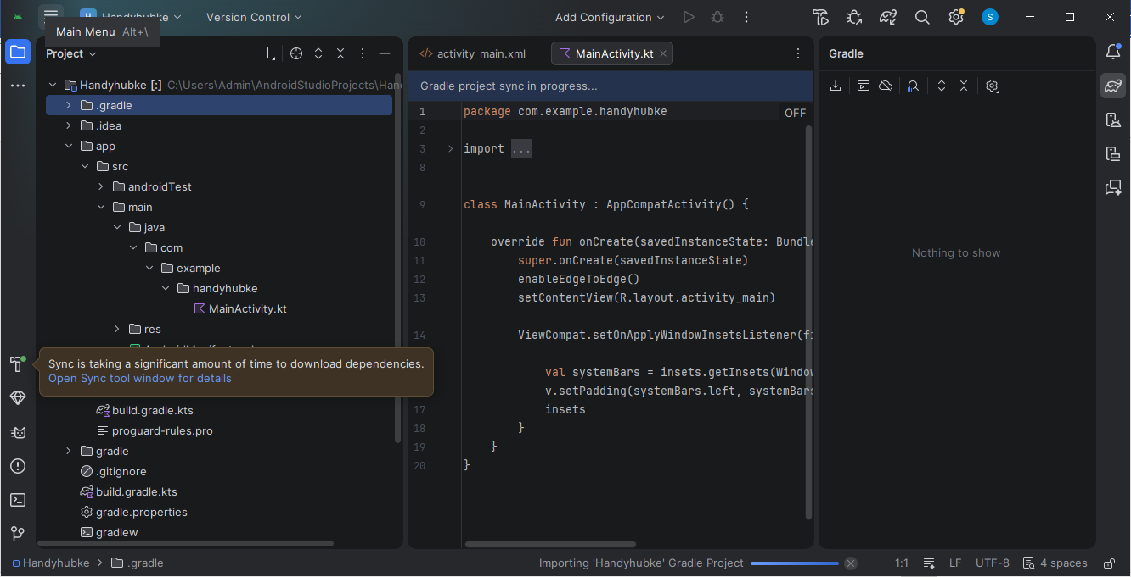
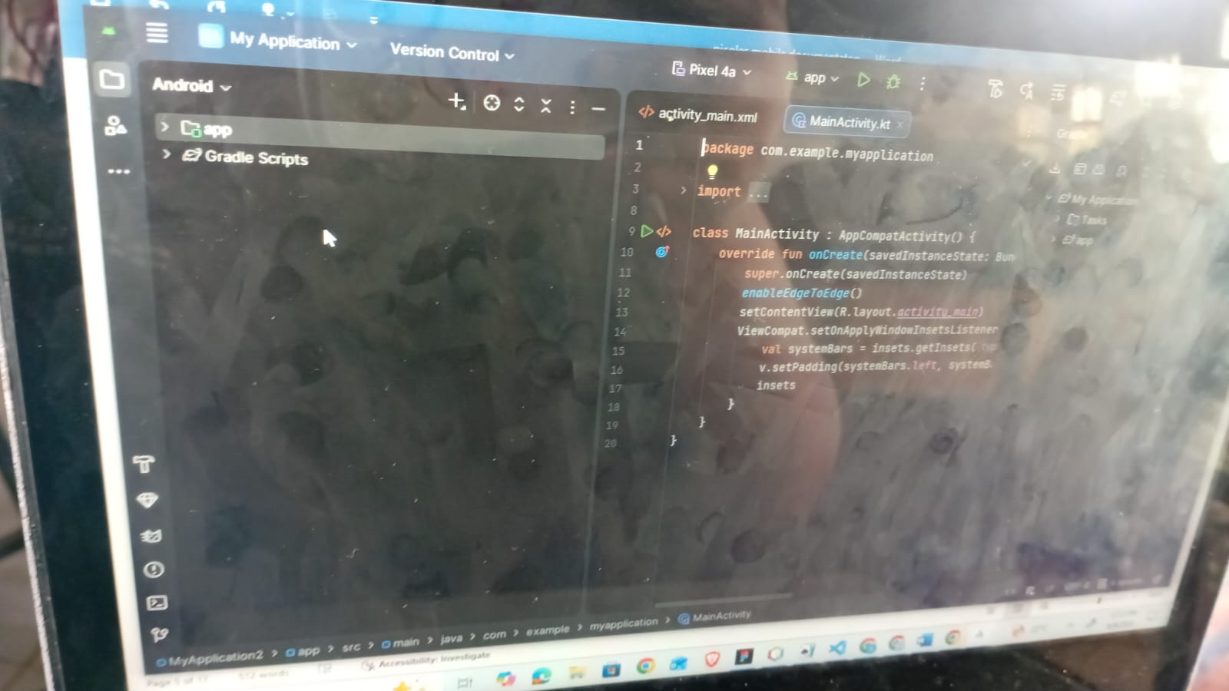
PERSONAL REFLECTIONS
Setting up the Android Studio development environment during week two was a foundational step. Successfully configuring the IDE and syncing Gradle dependencies allowed me to explore the project's file structure and main activity code. This process emphasized the importance of a properly configured environment for efficient development and troubleshooting

WEEK 3: USER INTERFACE DESIGN

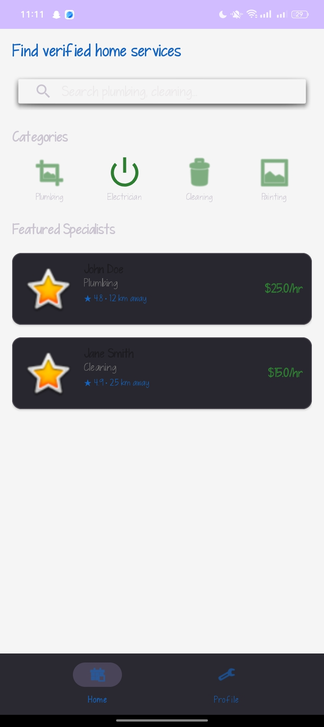
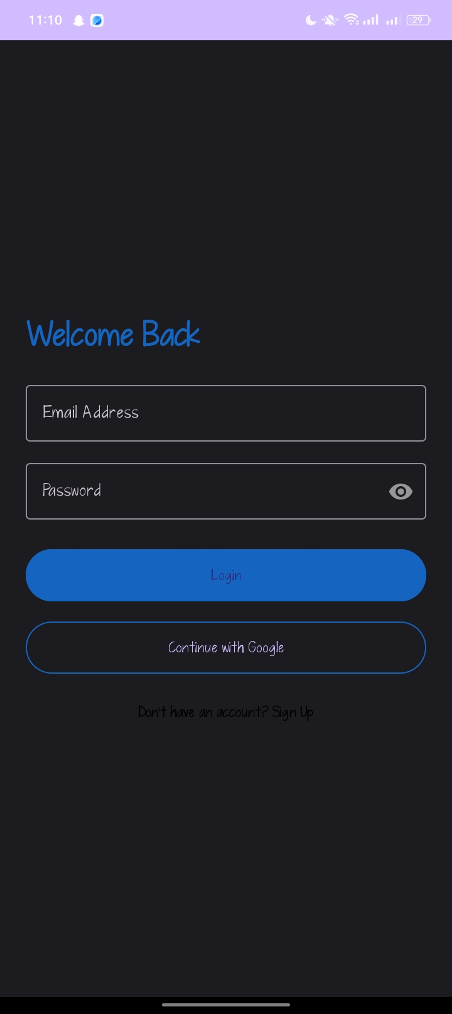

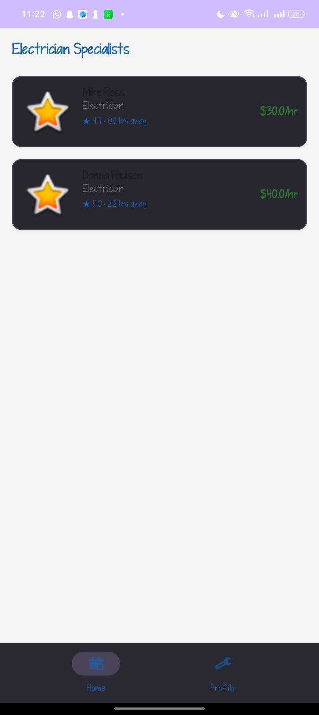
Personal reflection
Designing the HandyHub home screen in week three highlighted the power of User Interface (UI) design. Arranging the search bar, service categories, and featured specialist cards taught me how layout choices directly shape user experience. It was a lesson in balancing clean aesthetics with functional, intuitive navigation.

